Transformation matrix determination using XPREP

To verify that the cell parameters determined by RSV are the best representation of the overall lattice you will need to import an .hkl file and the unit cell into XPREP. The first step is to export the .hkl file from RSV and this is done simply by clicking the <Export> button in the File tab. A dialog box will pop-up and will allow you to save the file in the location and under the name of your choosing. The file name will need to end in .hkl.
Open a copy of XPREP by double clicking the bigxprep.exe icon. XPREP will first want to read the hkl file so you will need to type in the full pathway name of the file. If the file isn’t read, try copying the bigxprep.exe file into your data folder and try again using the new bigxprep.exe file. After the file is read, XPREP will need to know the type of file being read, take the default value of [4] for a HKLF4 file by pressing enter. Next you will need to type in the cell that you determined using RSV as “a b c α β γ”. Next XPREP will ask you for the centering preference. Hit enter to take the default value which is usually a primitive cell. Now a menu of several options is displayed and the default value [H] will be to search for higher metric symmetry. Hit enter to take this default value.

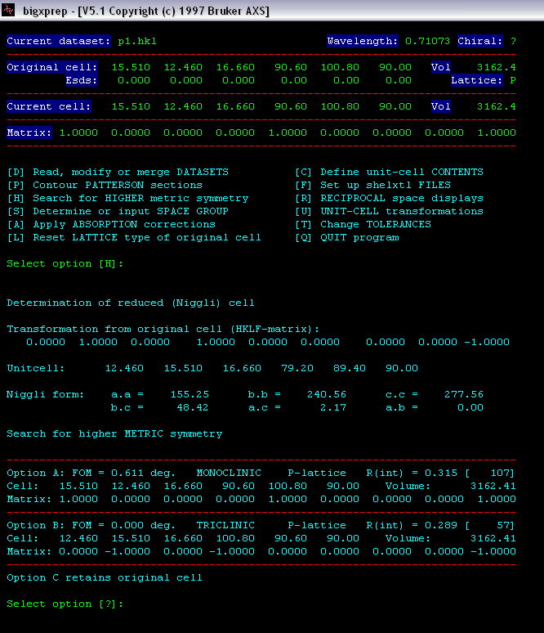

After the search, a screen similar to the one above will be displayed. The most important area is at the bottom which lists the different possible cells. In this example there are two possible cells, a triclinic and a primitive monoclinic cell. In each of the cell options there is a line starting with Matrix that contains the 3x3 matrix needed to transform the original cell to the chosen cell. Take note of the matrix that you would need and type Q to quit the program. XPREP automatically writes an output file (name.prp) which contains the steps that were taken in XPREP including the all of the possible cells for this reflection file. This makes it possible to recall the transformation matrix without needing to run XPREP again.
Now that you have the transformation matrix you are ready to transform your lattice parameters in RSV to the best representative unit cell. Return to RSV and make sure that your peaktable and UB matrix are loaded. In the Index tab there is a sub-menu for transforming the lattice parameters. In the Transform tab there is a 3x3 matrix in which you will need to type the transformation matrix determined by XPREP. To properly enter the matrix in RSV, fill in the dialog boxes horizontally with the first three numbers in the first row, the next three in the second row and the last three numbers in the third row. Next you will need to invert the matrix by clicking the <Invert> button and then you can transform the lattice parameters by clicking the <Transform> button. It is a good idea to save your new matrix at this point.

